Travel Troop Trip
April 16, 2026
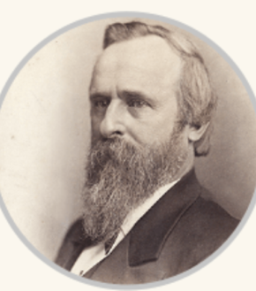
Celebrate Our 250th Year
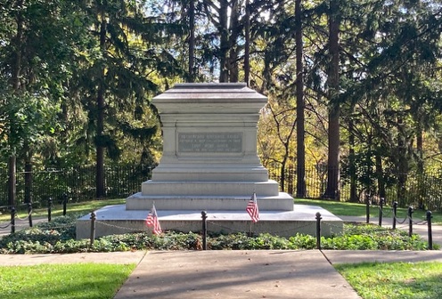
Site of the nation’s first presidential library, Rutherford B. Hayes Presidential Library & Museum in Fremont, Ohio, also includes our 19th president’s 31-room mansion, a two-story museum and the site where President Hayes and first lady Lucy Webb Hayes are buried.
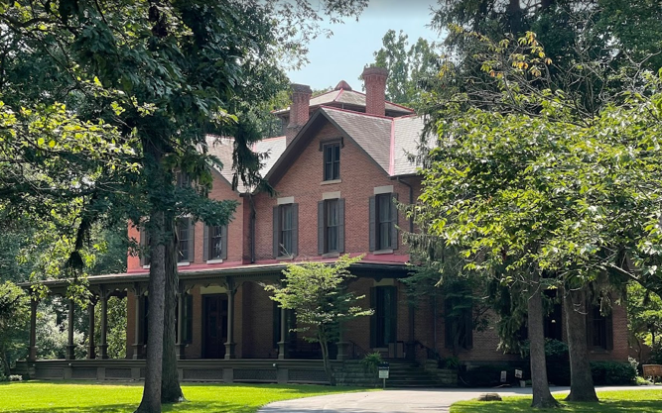
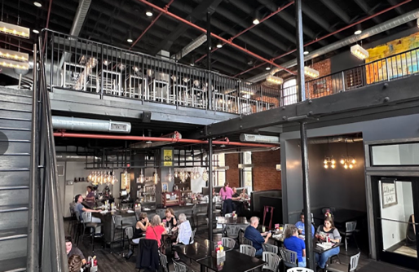
We will have a guided tour of the Victorian-era Hayes home, a National Historic Landmark restored to its appearance during the president’s lifetime. In the nearby Hayes Museum, explore exhibits featuring artifacts from the president’s life and administration, the Civil War and all presidents of the United States, plus a magnificent weapons collection. https://www.rbhayes.org. This trip involves a considerable amount of standing and walking for extended periods.
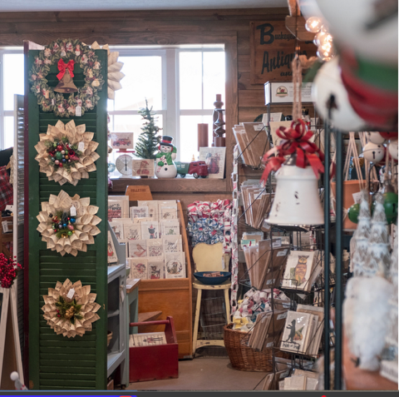
Lunch will be at The Garrison in Fremont before we go to the Hayes Presidential Library and Museum. https://www.the-garrison.net/. This is a 126-year-old structure and, as a restaurant, serves a Euro/American Bistro style menu. The Garrison features a wood fired grill with a variety of different food options.
On the way home, we will stop at The Pickwick Place in Bucyrus. The Market Place and The Stalls are in 3 restored brick barns of an old horse farm. You will find unique handcrafted artisan wares and antiques from vendor stalls, and stock up on your favorite Ohio-made foods from the Market.
This day trip will start at 8:45 AM at the Panera lot at the Worthington Shops. We will arrive back in Columbus at 5:15 PM. The cost of the large Cardinal bus with bathroom, driver tip, and entrance fee to the Hayes Library & Museum, is $70. Lunch and shopping of course is on your own.
Unfortunately, we need to limit the number of attendees to 30, so please let us know if you intend to travel with us to celebrate the 250th anniversary of the United States. Contact Sandy Cornett at 614-325-0008 or cornettsandy22@gmail.com by March 1 if you plan to attend or have questions or concerns.
Best,
Sandy Cornett & Patti Shilling

