Fall Trip to Lebanon Ohio
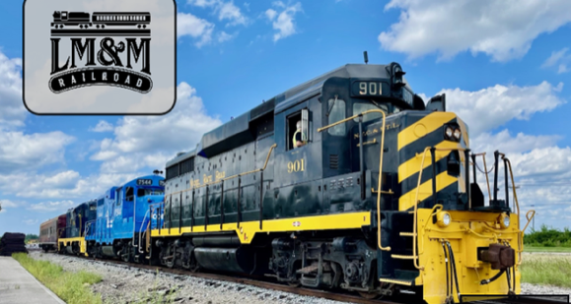
October 16
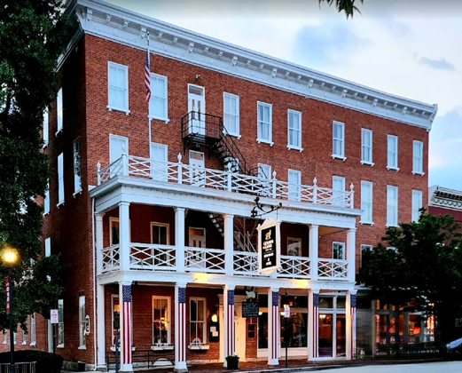
Please join us for a fun day in Lebanon Ohio on October 16. We will be riding the Lebanon-Mason-Monroe Railroad on the Turtle Creek Valley Flyer Excursion for 1 hour & 15 minutes through the Warren County countryside to view the beautiful fall leaves.
Once we are done at 12:15 pm we will have lunch on our own at the Golden Lamb (www.goldenlamb.com) or one of many other restaurants in the town. Some of these include Village Parlor, Cherry Street Café, Doc’s Place, and The Breakfast Club. (https://www.tripadvisor.com/Restaurants-g50541-Lebanon_Ohio.html)
We need to know if you want to eat lunch at the Golden Lamb so reservations can be made. Only 10 seats could be reserved now on a first come first served basis. We will try to get a second table of 10 if there is enough interest.
Since 1803, the Golden Lamb has been a gathering place — for neighbors, travelers, statesmen, presidents, families and friends. Legacy runs deep, infused with the spirit of hospitality, accented by the flavors of history, and framed by inspiring events. For more than 220 years, guests have been delighted with excellent service and memorable food and drink in an atmosphere found nowhere else.
After lunch, shop at the many boutique shops up and down N. Broadway where the restaurants are located. For $10 visit the Harmon Museum across from the Golden Lamb. Explore four art galleries, prehistoric artifacts, the finest collection of Shaker artifacts and archives in the Midwest, a recreation of an 1800s town square, an extensive textile collection with items as far back as 1740, and the newly renovated Archeological & Indigenous Peoples Exhibit, called "one of the finest collections outside of the Smithsonian's.”
TRIP DETAILS:
- Arrive at Panera parking lot at Worthington Mall by 8:15 am
- Bus leaves parking lot at 8:30 am
- Arrive at Lebanon Train Station at 10:00 am. Time for rest room, shop at gift shop, seat assignments, etc. Train leaves at 11:00 am and returns to station at 12:15 pm.
- Lunch and shopping or Harmon Museum on your own downtown 12:30-3:00 pm. Walking up to 2 blocks and climbing stairs is required.
- Bus leaves from The Golden Lamb at 3:15 pm.
- Arrive in Worthington at 4:45 pm.
COST: We need to know of your interest as the cost may change depending on the number of attendees. Please do not send money yet. If all 22 seats are filled on the bus, the cost will be $82 which includes the train ticket and bus + tip for driver. Please contact Pam Clawson if you intend to join us or if you have any questions or concerns. Contact: pamclawson@sbcglobal.net or 614-783-3561.

