Santa Claus: The Musical & The Gift of Christmas

Two joyous musicals for the price of one!
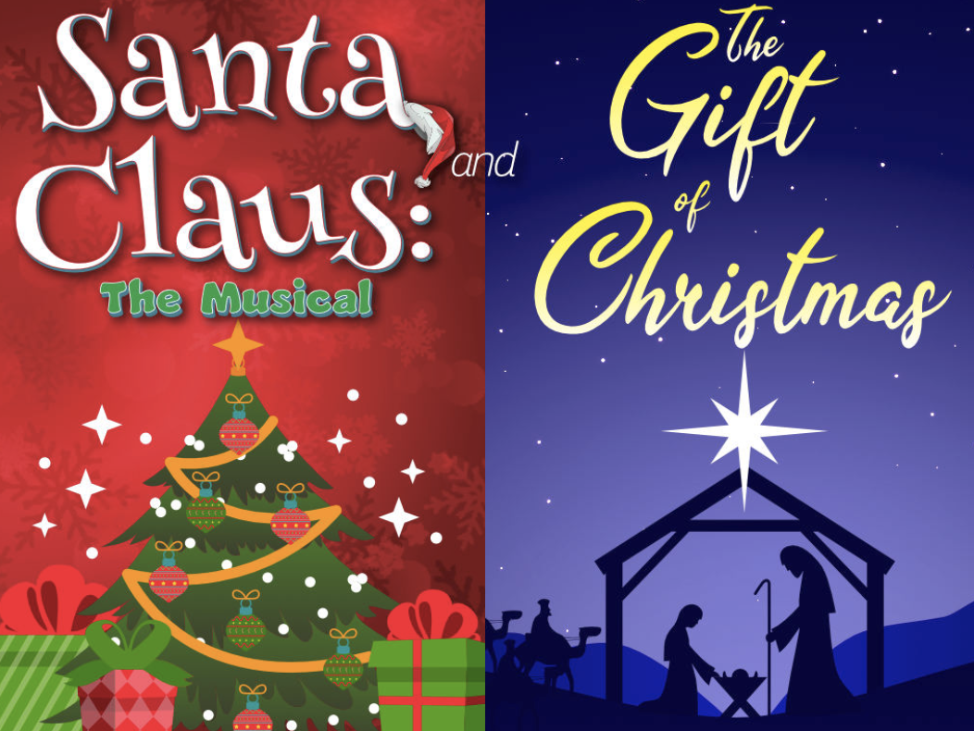
The first act for the holiday celebration is Santa Claus: The Musical. Santa has decided to retire but not all the elves in his workshop are thrilled with his chosen replacement. Packed with a sleigh-full of original Christmas music, Santa Claus: The Musical is sure to put you in the holiday spirit!

After intermission, The Gift of Christmas is presented. This dramatic celebration of the true meaning of Christmas is highlighted by a musical narrative of the Nativity told through traditional carols and hymns. This unique Christmas celebration concludes with our traditional rendition of “O' Holy Night.”
WHEN: December 17, 2026
WHERE: La Comedia, Springboro, OH
COST: $105 depending on number of attendees (35 seats are available and we need 33 attendees to break even, or we will need to cancel the trip). Cost includes bus, driver tip, lunch, show, and server tip.
SCHEDULE:
- Meet at the Panera parking lot at Worthington Mall by 8:45 AM.
- Bus leaves at 9:00 AM. Arrive at La Comedia 10:30 AM.
- Lunch Buffet 11:15 AM. Check out the extensive menu at https://lacomedia.com
- Show 12:30 PM.
- Leave for home about 3:00 PM and arrive home about 4:30 PM.
Please make your check paid to Patti Shilling and send to 328 Heritage Loop, Lewis Center, OH 43035 by November 12. For questions contact Patti at (419-573-1106) pshilling53@gmail.com.

